
Ramapost

Volume 1, Issue 1 A Publication of the Ramapo High School Alumni Association October 2001
Recent Grad Wins Cross Country Championship
Jennifer Myers, class of 2001, is an all-state athlete who holds every Ramapo all-time Cross Country record, as well as many in track. On May 29th, 2001, just a few weeks before her graduation, Jen earned the title of County 3200 Champion when the Bergen County Meet of Champions was held on Ramapo's brand new composition track. Jen will continue running this fall at Old Dominion, where her extraordinary track and cross country skill earned her a scholarship.
Jen is not the first in her family to run for the Raiders. Inspired by the then Eastern US Champion John Loeschhorn (class of 1962), Jen’s father, John Myers was a member of the track and cross country teams during his years at Ramapo, admittedly, not as successful as his daughter! John graduated in 1964 and is one of the few alumni who remain in Wyckoff today. His son James also attends Ramapo and will be a sophomore this year.
Ramapo Families
Do you know of other alumni whose children have also attended Ramapo? We’d like to know.

Welcome! From the President’s Desk
I'd like to welcome all of you to the inaugural issue of the Ramapost. This newsletter, alumni web site, and the association are for everyone to use to keep in contact with classmates and friends. I hope all of you take advantage of what is available and continue to provide information on those still not located.
I would like to personally thank all alumni who have supplied us with donations and information over the past two years enabling us to make this a reality. A special thank you to the folks at Newstyle Media who redesigned our web site and are now hosting us pro bono.
Last but not least, thanks to our association officers and newsletter staff, including Ginny (Palmieri) Debbink, Dorothy (Witowich) Gillman, Al Longden and Cathy (Palmieri) Risse. Without their dedication and hard work this newsletter would still be a dream. For me, this has been one of the most rewarding experiences of my life. I thank all of you for allowing me the opportunity to share my dream with you.
Ed Pepling (’64) Webmaster@rrhsalumni.org
An Interview with the Founder
By Ginny (Palmieri) Debbink
Ed Pepling is not the most likely person to have founded the Ramapo High School Alumni Association. Ed had lived in Midland Park through the end of ninth grade, and began his three years at Ramapo as a sophomore. “Friendships,” he notes, “Are well established by then.” He found it difficult to make friends in his new school. Although Ed found something of a home in the music department, and carved a niche for himself in the marching and concert bands, he always felt like an outsider at Ramapo. “Classes with Bill Collins (band director) and Jerome Segal (chorus and music teacher) kept me sane,” he remembers, and he put in lots of time taking music classes. Still, when Ed graduated from Ramapo (then Ramapo Regional) High School in 1964, like many other high school graduates, he did so with no regrets about leaving and no intentions of ever looking back.

After Ramapo, Ed immediately joined the Navy. He put in three years of active duty before being honorably discharged in 1967, just before turning 21. Following his time in the service, Ed enrolled in technical school, and learned the computer skills that have served him well throughout his life. He began his career as a data processing manager shortly thereafter, working for many years in New York City and New Jersey. In 1983, he took a position with the Department of the Army, where he has been ever since. This position has taken him all over the world, and afforded him many opportunities and much enrichment. Ed plans to retire in September of this year (which will afford him much more time to devote his energies to the Ramapo High School Alumni Association.)

In 1998, Ed was contacted by the Midland Park H.S. Alumni Association with an invitation to become a member of their newly organized group. He joined the young association, and began to wonder if Ramapo High School had a similar organization. To his surprise, he discovered it did not. He had not thought much about his high school days, and since his 1964 graduation, he had not had contact with anyone from Ramapo. Thinking about high school days again, he began to wonder about old friends, and idly curious, Ed logged on to Classmates.com (http://www.classmates.com) to see if he could find anyone he had known. To his delight, he stumbled upon the name of old friend, Johanna Dolan (’63.) He and Johanna had been good friends during their Ramapo days, and they began an e-mail correspondence. Johanna shared the e-mail address of mutual friend Tony Baumgarten (’65) with Ed, and the three of them began talking about the possibility of getting together. In March, 1999 the three old friends met in New Jersey for dinner.

Ed never would have thought to look for old friends from high school if it hadn’t been for that unexpected phone call from the Midland Park High School Alumni Association. The renewed friendships with Johanna and Tony were so rewarding that after their reunion dinner, Ed was inspired to start an association for Ramapo alumni. With nothing more than the yearbooks from 1963 and ’64 as resources, Ed began. He took the names from those yearbooks to Classmates.com, and commenced his search. By May 22, 1999 he had located approximately 20 people. Today, as RHAA is ready to officially incorporate, Ed has listed almost 15,500 names on the Ramapo Alumni website (http://rrhsalumni.org,) a figure that represents almost every student who ever attended the school. Of these, Ed has contact information for about 5,100 Ramapo alumni, located in 50 states and 18 foreign countries.

Ed’s goal is to reach as many Ramapo alumni as possible, both through this newsletter, and through the web site. He has great plans for the future of both. If you haven’t visited the web site yet, you should do so. It is, as most web sites claim to be, a work in progress, with the hopes of one day serving as a valuable communication tool for all Ramapo graduates. Future developments planned for the page are a birthday page, with the month and day of every graduate’s birthday, listing them by name and class year, with an e-mail link to click if someone wishes to send them birthday greetings. Hopefully, the class listings will one day be enhanced with audio files, playing the top 5 tunes from each graduation year, with links to vendor pages where one could purchase the CDs. Currently, the message board enables people to contact long lost friends, or one can send Ed e-mail to obtain contact information for any individual who has given him permission to share it.

The work that Ed has already put into the site has earned him the right to have the page linked to by Classmates.com. Classmates has over 30,000 schools listed on their web site. At last count, the page links to only 75 individual high schools’ pages. They will only consider linking to a page that they consider a true alumni site. The work that earned Ramapo’s web site this recognition was the work of one man – Ed Pepling – a lonely sophomore transfer who never realized until thirty-seven years had passed how much he really had gotten from Ramapo.

“The whole thought of the Association,” Ed says, “is to give back to the Ramapo community.” This is the primary reason for the existence of this newsletter. The dues of $15.00 entitle members to two issues per year of the hard copy newsletter. Brief highlights will appear on the web page, but complete stories, personal and class news can only be read in the hard copy version. One third of the dues will go toward the publication and mailing costs of the newsletter. Two thirds will go to cash awards for deserving seniors. This newsletter and the cash awards will be strictly an effort of the Alumni Association, but plans are to work closely with the Association of Parents, Teachers and Students (APTS) on other projects. Possible fundraisers, which would be co-sponsored by RHSAA and APTS, include book sales and the production of Ramapo merchandise, such as hats, t-shirts, and umbrellas. This merchandise would be made available through the RHSAA via the web site. An alumni get-together, including a football game, would give RHSAA members a chance to see one another annually, rather than waiting for 5 or 10 year intervals for class reunions, and would lend true meaning to a Ramapo “Home Coming” event.

Currently, efforts are underway by the RHSAA board to incorporate, and to attain approval from the federal government for 5013C status. Once that approval is granted, the Association can file for tax-exempt status with the New Jersey Charities Commission. At that point, all donations and dues will be tax deductible.

All of this seems nearly impossible to attribute to the efforts of a single man, borne out of a chance phone call from a different high school which he attended for only one year, yet that is the truth of it. Ed Pepling is a man who gets things done. Fortunately for us, the alumni of Ramapo High School are the beneficiaries of Ed’s current vision.

Inside This Issue
1 | Welcome Message from the President’s Desk  How to Contact the Alumni Association  By Mail:  Ramapo HS Alumni Association, Inc.  P.O. Box 75  Franklin Lakes, NJ 07417-0075  Website:  www.rrhsalumni.org  E-mail:  Webmaster@rrhsalumni.org  Contributions for next Ramapost:  News@rrhsalumni.org
1 | Recent Grad Wins Cross Country Championship
1 | How to Contact the Alumni Association
2 | In Memoriam
3 | An Interview with the Founder, Ed Pepling (’64)
5 | News from Your Classmates
6 | Association Registration
6 | Upcoming Events
7 | Alumni Advertising
8 | APTS
9 | Brick Fundraiser Logos
10 | Brick Fundraiser Order Form

In Memoriam

A Message From

the Principal

Dear Alumni:

Surely there must have come the moment, as it comes to all of us, when you turned your mind toward the days of your youth. It was inevitable in such a reverie that you returned to the school that played such a major part in your life at that time. Indeed, you and your school are intrinsically a part of each other. The current Ramapo community and your fellow alumni are eager to learn more about your current and professional endeavors.

This Alumni newsletter has been especially prepared for you, the alumnus of Ramapo High School. You will find within its pages the news and updates of your friends and what is happening to them, developments in and around the high school, and upcoming events and activities which you may wish to attend.

Here's hoping that the memories of your Ramapo High School days are happy ones, and that we will have the pleasure of seeing you at one of our alumni functions in the future.

All best wishes,

Dr. Mark C. DeMareo
Principal

CLASS OF 1957
Thomas Gray
Edward Kuiken
Peter Mowerson
Virginia Pulis
Calvin Ramsey
Lucille Vermeulen
David Wilson
Edward Wuster, Jr.

CLASS OF 1958
Roy Albinson
Hans Borchardt
Samuel Braen, Jr.
Leonard Buys
Angela Collado
Christine Husby
Tonette Kowal
Thomas La Vecchio
J. Kevin Lennon
Richard Masker
Joe Nelson, Jr.
Barbara Robertson
Paul Slingerland

CLASS OF 1959
Diane Conti
David Dentz
Marie Harbeck
William Holbert
Barbara Horvath
Kenneth Larson, Jr.
Charles Megnin
Russell Neumann
Elsie Olszewski
Susan Tobey
Judith Van Beekum

CLASS OF 1960
Kathryn La Vecchio
Harold Penney
Bruce Peters
George Pillar
Lorena Pulis
Louis Scaglione
Gail Trautmann

CLASS OF 1961
Austin Campbell
Louis Carbone
David Christie
Beverly Hines
Charles Kuhn
Kenneth Kuyper

Diane Malouf
Sandra Merkel
Robert Polhemus
John Stevenson
William Steves
Joan Van Grouw

CLASS OF 1962
Janet Daniel
Bradley Degenaars
Anthony DeMarco
Kenneth Erdman
Margaret Goldsmith
Judy Hanenburg
Joy Johnson
W. Bruce Knapp
Barbara Neill
Francis Siegal
Patricia Smith
William Sprague
Robert Teevan
Georgia Vandervelt
John Van Eerde

CLASS OF 1963
Frank Buys
Edward Doremus
Susan Hasslinger
Linda Mylenki
Wesley Searle
Barry Seifert
Randolph Singleton
Raymond Theiss

CLASS OF 1964
Carla Castiglione
Eric Fortsch
Barbara Gray
Michele Janas
Donald Jennings
Margaret Jugel
Robert Keller
Florence Loeshhorn
Patricia McNinch
Lynn Neer
Rosanne Orlando
Douglas Pelton
Paula Schnabel
Craig Stillwell
Fred Watson

CLASS OF 1965
Eric Alletag
Paul Bauer
Kathleen Coburn
Susan Gerosky
Jill Jackson
Robert Maeser
Alan Najar
Kathleen Neill
Robert Robertson
Robert Schamberger
Richard Unglert

CLASS OF 1966
Robert Gallopo
Bruce Struck

CLASS OF 1967
David Beers
Linda Bowe
Carolynn Danzer
Martha Davison
Marc Doherr
James Giegel
Timothy Murphy
Casimir Slonski
Bruce Sterne
William Stinson, Jr.
Verne Tobler
Edward Winters

CLASS OF 1968
Glenn Feaman
Bruce Nicholson

CLASS OF 1969
Flora Blauvelt
Rick Gallo
William Gordon
Susan Shafnacker
Donald Voorhis
Lucy Wicks
Diane Will

CLASS OF 1970
Arthur Auger
David Cole
Patricia DeLuca
Keith Dunham
Phillip Hayes
Guy Kellogg
Thomas Kennedy
John Landaas
Raymond Michel
James Monroe
Barbara Morelli
Patricia Najar
Lorraine Pittala
John Psiaki
McClain Ramsey
David Sinclair
Marianne Siss

CLASS OF 1971
David Cole
Eileen Fischer
David Hunt
Ted Neal
Marysue Remo
Elizabeth Sterrett

CLASS OF 1972
Mike Becker
Nancy Duff
Scott Dykstra
Jeffrey Kauflin
Paul Koukos
Gail Lawrence
Priscilla Leonard
Tom Magura
Meg Marotta
Eileen Ruthlein
Barry Speck
Beth Williams
Rick Zender

CLASS OF 1973
Barbara Bockhorn
Mark Robinson
Gary Shea
Mark Sweetman

CLASS OF 1974
William Evans
Alan Giannini

CLASS OF 1975
James Churco
Jaqueline Covals
Edward Fuller
John Hamilton, Jr.
Tina Lohse
Joyce Stafford
John Stein
Bradley Voss

CLASS OF 1976
John Campana III
Patrick Campbell
Jonathan Eddy
Peter Hayes
Chris Orleanski
Gary Terpstra
Jill Van Hook

CLASS OF 1977
Sal La Bua
Tyler McRae
David Morgan

CLASS OF 1978
David Brady
Andrea Cella
Lynnette Hein
Steven Herz
John Jacobus
Pamela Kreiter
Katie MacNaughton
Millicent Peck
Carol Wilson

CLASS OF 1979
Douglas Blum
Linda Doran
Paula Nelle
Dawn Weinheimer

CLASS OF 1980
David Brandon

CLASS OF 1981
Andrew Malcolm

CLASS OF 1982
Eileen Bell
Brian Joseph Bowers
Joe Di Maria

CLASS OF 1983
Daniel Brady
Carin Cantilina

CLASS OF 1984
Michael Baliga
John Farnan
John Herz

CLASS OF 1985
Chris Tortorelli

CLASS OF 1986
Kevin Sheehan
Alexia Tsairis
Meredyth Winter

CLASS OF 1987
Christopher Cochran

CLASS OF 1988
Kevin Loudon
Sara Manley
Bradley Martin
William McAlevey
Kenneth McParland

CLASS OF 1989
Scott Bloom
Corinne Gagliardi
Lorin Konner

CLASS OF 1990
Dana Hannon

CLASS OF 1991
Robert Bach
Carol Birdsill
Shari Kandell

CLASS OF 1992
Scott Smith

CLASS OF 1995
Richard Couser

CLASS OF 1996
Michael Wiley

CLASS OF 1999
Brian Kielt

CLASS OF 2000
Agnes Carabello

CLASS OF 2002
Ryan Rezvani

Continued on page 4

Continued on page 11

In Memoriam (Continued from page 2)

News from your classmates!

* * * * * * * * * * * * * *

Tell us what you’re up to! Send your news to news@rrhsalumni.org or drop us a note in the mail and we’ll include it in our next edition of the Ramapost.

* * * * * * * * * * * * * * *

Ralph Anzelmo (’64) attended Albright College in Reading, Pa where he played basketball and track. He graduated from Montclair State in 1968 with a BA MATH ED. He then taught math in Parsippany from 1968 until he entered the Marine Corps in 1971. Ralph flew EA-6 aircraft as an Electronic Countermeasures Officer for 4 years and spent 25 years as a Data Systems Officer.

While in the service, he earned an M.S. in Data Systems in 1977 from the Naval Postgraduate School, as well as an M.S. in Business Management in 1990 from Salva Regina College. Since retiring from the USMC in 1999, Ralph has been employed as a math teacher at an alternative behavior high school in Virginia.

Ralph is divorced, has 3 children and 6 grandchildren. He enjoys spending time with his grandchildren and playing basketball, softball and waterskiing. He recalls being very strongly influenced by Mrs. Owens (head of the Foreign Language Dept. at Ramapo in 1964) and Mr. George Berger, coach and Phys Ed teacher in Franklin Lakes Elementary School, both of whom he has stayed in contact with.

John C Betka (’64) writes that he was married three times, raised his two girls as a single dad because “women today stink”, and he finally found a good normal woman – his current wife. One of his daughters is in executive management while the other is heading into Harvard Law Schools.

John writes:
I am a CEO of a International Company supplying Arms and Munitions to NATO and Military Special Forces, we are making weapons for the “Good Guys”. I am a Combat Vietnam Veteran, disabled, and love the Vietnamese, dislike Americans that turned their back on American Soldiers. Have a Ranch in Arizona, wife does International Graphics and Medical Artwork for multitude of agencies, latest is the Leukemia Drug that was just announced "GLEEVIC" her work. God, First, Family Second, 2nd Amendment Third - Three BEST things to believe in.

Bill Quackenbush (’72) has been located in Newburgh [Orange County] New York for 20+ years. He taught undergraduate finance for 7 years, was a bank president for 8 years and had his own consulting company for most of the last 10 years. Currently he is a business appraiser, providing expert witness testimony in litigation matters and documentary support for IRS estate and tax issues.

Bill has been married for 27 years to Robin, who is from Newburgh. They have four daughters, 18 to 24 [the oldest adopted], one of which is married, but as Bill says, “No grandchildren yet <yikes!>”

Cathy (Palmieri) Risse (’77) attended St. Bonaventure University where she earned a BBA. After 12 years in the field of commercial real estate appraisal, she joined Merck-Medco in Franklin Lakes where she is currently a Manager in Information Strategies and Development. She is working toward an MBA at William Paterson University, and is also pursuing EMT certification while volunteering for the Wyckoff Ambulance Corps. She and her husband were married in 1996.

Karen Blum Anthony (’79) keeps very busy by raising her 9 year old triplet sons, as well as teaching in her local school district in upstate NY. She received her teaching degree in 1982, got married in 1987 and stayed at home from 1992 to 1998 to raise the triplets. Her husband works for the Albany county Sheriffs Dept.

Carin Sappelli-Jones (’82) sadly reports that she became a widow on 4/3/01.

Laurie Williams Harding ('86) went to Green Mountain College and graduated in May of 1990 with a degree in Special and Elementary Education. She married Bill Harding in March of 1994 and they now have a son Nicholas, born January 2, 1996, and a daughter Morganne Emily, born March 1, 2001. Laurie writes, “I currently have the best job of all, I am a stay at home mom to my two children.”

Nancy Sierakowski (’88) was married on 4/29/01 in Parsippany, NJ, at the Knoll Country Club.
1LT Ron Anzalone (Class of ’94) was engaged last December to Miss Emily Kalny of Whitehall, PA. The two met at the University of Scranton. They presently live in Tennessee where Ron is stationed at Ft. Campbell. He serves as an Executive Officer to an Infantry Rifle Company with the 101st Airborne Division.

Jamie Casanova (’97) graduated cum laude from Susquehanna University in Selinsgrove, PA, with a Bachelor of Science in Elementary Education. She worked this summer as an intern at Sony headquarters in Park Ridge, NJ, in their Communications department. She has started her career as a third grade teacher this month at the Woodside Ave. Elementary School in Franklin Lakes.

Continued on Page 11
Join the association
Here’s how
- Register and Join the RHSAA
Send $15 annual dues along with the registration form below. After mailing costs, proceeds will be used for cash awards to be given to seniors. Members will receive two newsletters per year and their contact information will be made available to reunion committees. Future newsletters will include special offers and news of upcoming events.

- Just register
Mail in the registration form without the annual dues and your information will be made available to reunion committees. You will not receive any future newsletters. You can also register on-line at www.rrhsalumni.org.

- If you don’t register
Please understand that you will not receive any future newsletters, and you may not be contacted by any reunion committees.
Ramapo High School Alumni Association

Registration Form

First Name: Last Name:

Maiden Name: Class Year:

Street: City: State:

Zip: Phone #:

E-mail: Alt. E-mail:

Keep My Information Confidential: Date of Birth:

Check One: I want to be a member – my $15 is enclosed I just want to register
Make check payable to Ramapo HS Alumni Assoc.

(The Ramapo HS Alumni Association will never willfully disclose any information about its registered alumni to any third party other than other registered alumni. All registered alumni have the option of requesting that their information remain private without their express written permission for release.)
Please feel free to include any personal information for future editions of the newsletter!
- - - - - - - - - - - - - - - - - - - - - - - - - - - - - - - - - - - - cut along dotted line - - - - - - - - - - - - - - - - - - - - - - - - - - - - - - - - -
Upcoming Events:
First Annual Alumni Get Together – Join us at the final home football Game on Saturday, November 3rd, 2001.
Ramapo Raiders vs. Wayne Hills
Game time is 7pm and will be preceded by an alumni tailgate party at 5pm in the football parking lot (bring your own food).
Because this game is such an area rivalry, it will be televised by MSG. A special seating section will be reserved for all Ramapo Alumni. Please provide your anticipated headcount to : webmaster@rrhsalumni.org (or via mail) by 10/26/01 so we can reserve enough seats. This game is sure to draw a large crowd! Tickets are $3.00 for adults and $2.00 for senior citizens and children.
Reunions!

Class of 1961: 40-YEAR REUNION
A 40th year reunion is planned for sometime in 2001. Your reunion committee members are hard at work. Anyone wishing to assist or interested in attending should contact Stephen Cielusniak by e-mail at swciel@juno.com or regular mail at 5 Lavina Terrace, Wayne, New Jersey 07470.

Class of 1971: 30-YEAR REUNION
A 30th reunion was held on October 6, 2001 at the Woodcliff Lake Hilton in Woodcliff Lake. The class contact is Bruce Weber, who can be contacted at zoomweber@aol.com, whom you can contact if you were unable to attend the event to catch up with your classmates.

Class of 1981: 20-YEAR REUNION
A 20th year reunion is planned for Saturday, November 24, 2001 at the Radisson Hotel in Paramus, NJ. Please submit your name and address to: Reunions Unlimited, Inc., PO Box 150, Englishtown, New Jersey 07726

Class of 1991: 10-YEAR REUNION
A 10th reunion is planned for Friday, November 23, 2001 at the Wayne Manor, 1515 Route 23, Wayne, NJ. This reunion is being put on by Reunions by Design. Please contact them via e-mail at msg@reunionsbydesign.com for further details.
To submit future events information send an e-mail to news@rrhsalumni.org or mail information to:
Ramapo HS Alumni Assoc., Inc.
PO Box 75
Franklin Lakes, NJ 07417-0075
Two great gift ideas for sports fans of all ages!



ELVES CAN’T DUNK tells the story of Sebastian, a young basketball fan who decides to tryout for his favorite professional basketball team. Only there is a small problem – Sebastian is an elf and ELVES CAN’T DUNK. To solve his dunking dilemma, Sebastian takes some of Santa’s special feed corn, the stuff that makes reindeer fly, and heads for the tryout. This corn will give Sebastian more hang time than Michael Jordan on the moon! When Coach Frank Tanner finds out about the corn, he sets out on a mission to steal it from Santa Claus. Soon, its up to Sebastian and his friends Ralphy the polar bear, Holly the elf and Santa himself to catch Coach Tanner and save Christmas!

SAFE AT HOME – A BASEBALL CARD MYSTERY tells the story of Trevor Mitchell, an 11-year-old boy, whose aged great-grandfather gives him a 1915 Babe Ruth rookie card valued at $50,000. Trevor’s joy is threatened by the mysterious disappearance of the card and by his friends’ skepticism about great-grandpa’s claim of being the only man in baseball history to steal home off Babe Ruth.

ALUMNI ADVERTISING
Let us help you spread the word!
Written by Robert Skead (class of 1982), both stories teach valuable lessons about friendship and forgiveness. They are available for $5.95 at your local bookstore, via www.barnesandnoble.com, or by e-mailing Robert at www.robertskead.com. In addition, the books can be purchased by calling Cross Training Publishing at 800-430-8588.

Robert is married to another Ramapo Alumnus, Cherie Middendorf (class of 1987) and together they are looking forward to the publication of his third book that will be available later this month.

Experienced Travel Consultant
Carol Walder Storms (class of ’59)
WYCKOFF TRAVEL & CRUISES, Inc.
365 Franklin Avenue
Wyckoff, NJ 07481
(201) 891-4321
(201) 405-1649


LINDA A. BADKIN (Class of ’74)
Independent Distributor
Diet & Nutrition
Personal Care Products
PO Box 184 (631) 267-1025 phone
Amagansett, NY 11930 (866) 753-5494 Toll Free

WORK AT HOME
Home Based Business
$500-$3,000+/month PT-$3,000-$10,000+/month FT

- Control your hours & income
- Full Training & Support Provided
- Industry Leader, Traded on NASDAQ
Call: (888) 923-4843 for free booklet
Or visit www.BreakFreeAtLast.com

  APTS  

The Association of Parents, Teachers and Students (APTS) is dedicated to the enriching the educational experience of all students. Through its fundraising efforts, the APTS provides funds for technology, staff requests, social and extracurricular activities for students, and provides scholarships for graduating seniors. The APTS also serves as a communication and information source for parents, teachers and students alike, and works with class advisors to address challenges facing today’s students.

The APTS is currently selling bricks which will be laid to form a walkway in the front circle of the school. The bricks can be purchased and personalized with your name and/or other text up to 3 lines, as well as with or without a logo as shown on the following page. The order form appears on page 10 of this newsletter.

Instructions for ordering bricks appear at the bottom of the order form.

It is with great sadness that we report the loss of the following alumni in the tragic events of September 11, 2001:
David Brady (’78)
Sara Manley (’88)
Dana Hannon (’90)
Shari Kandell (’91)
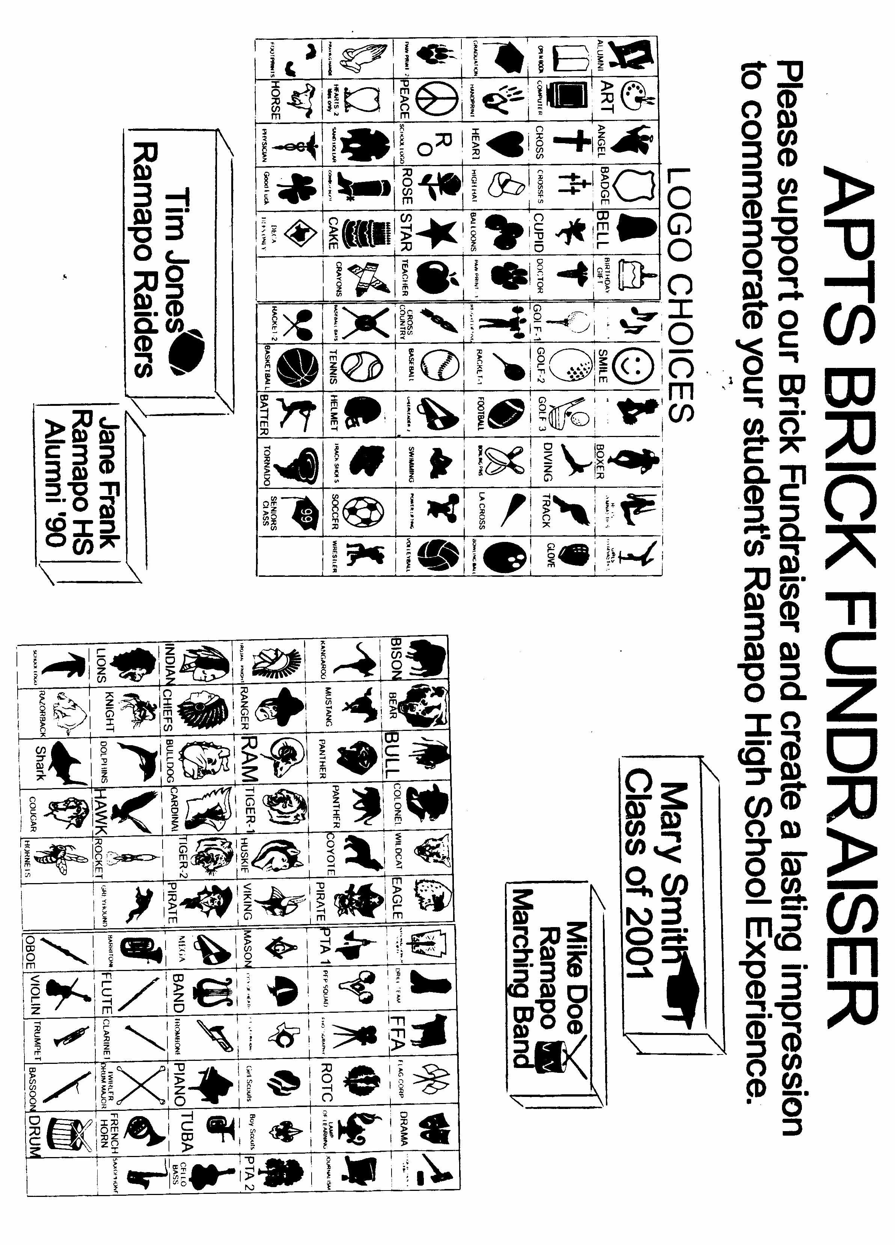
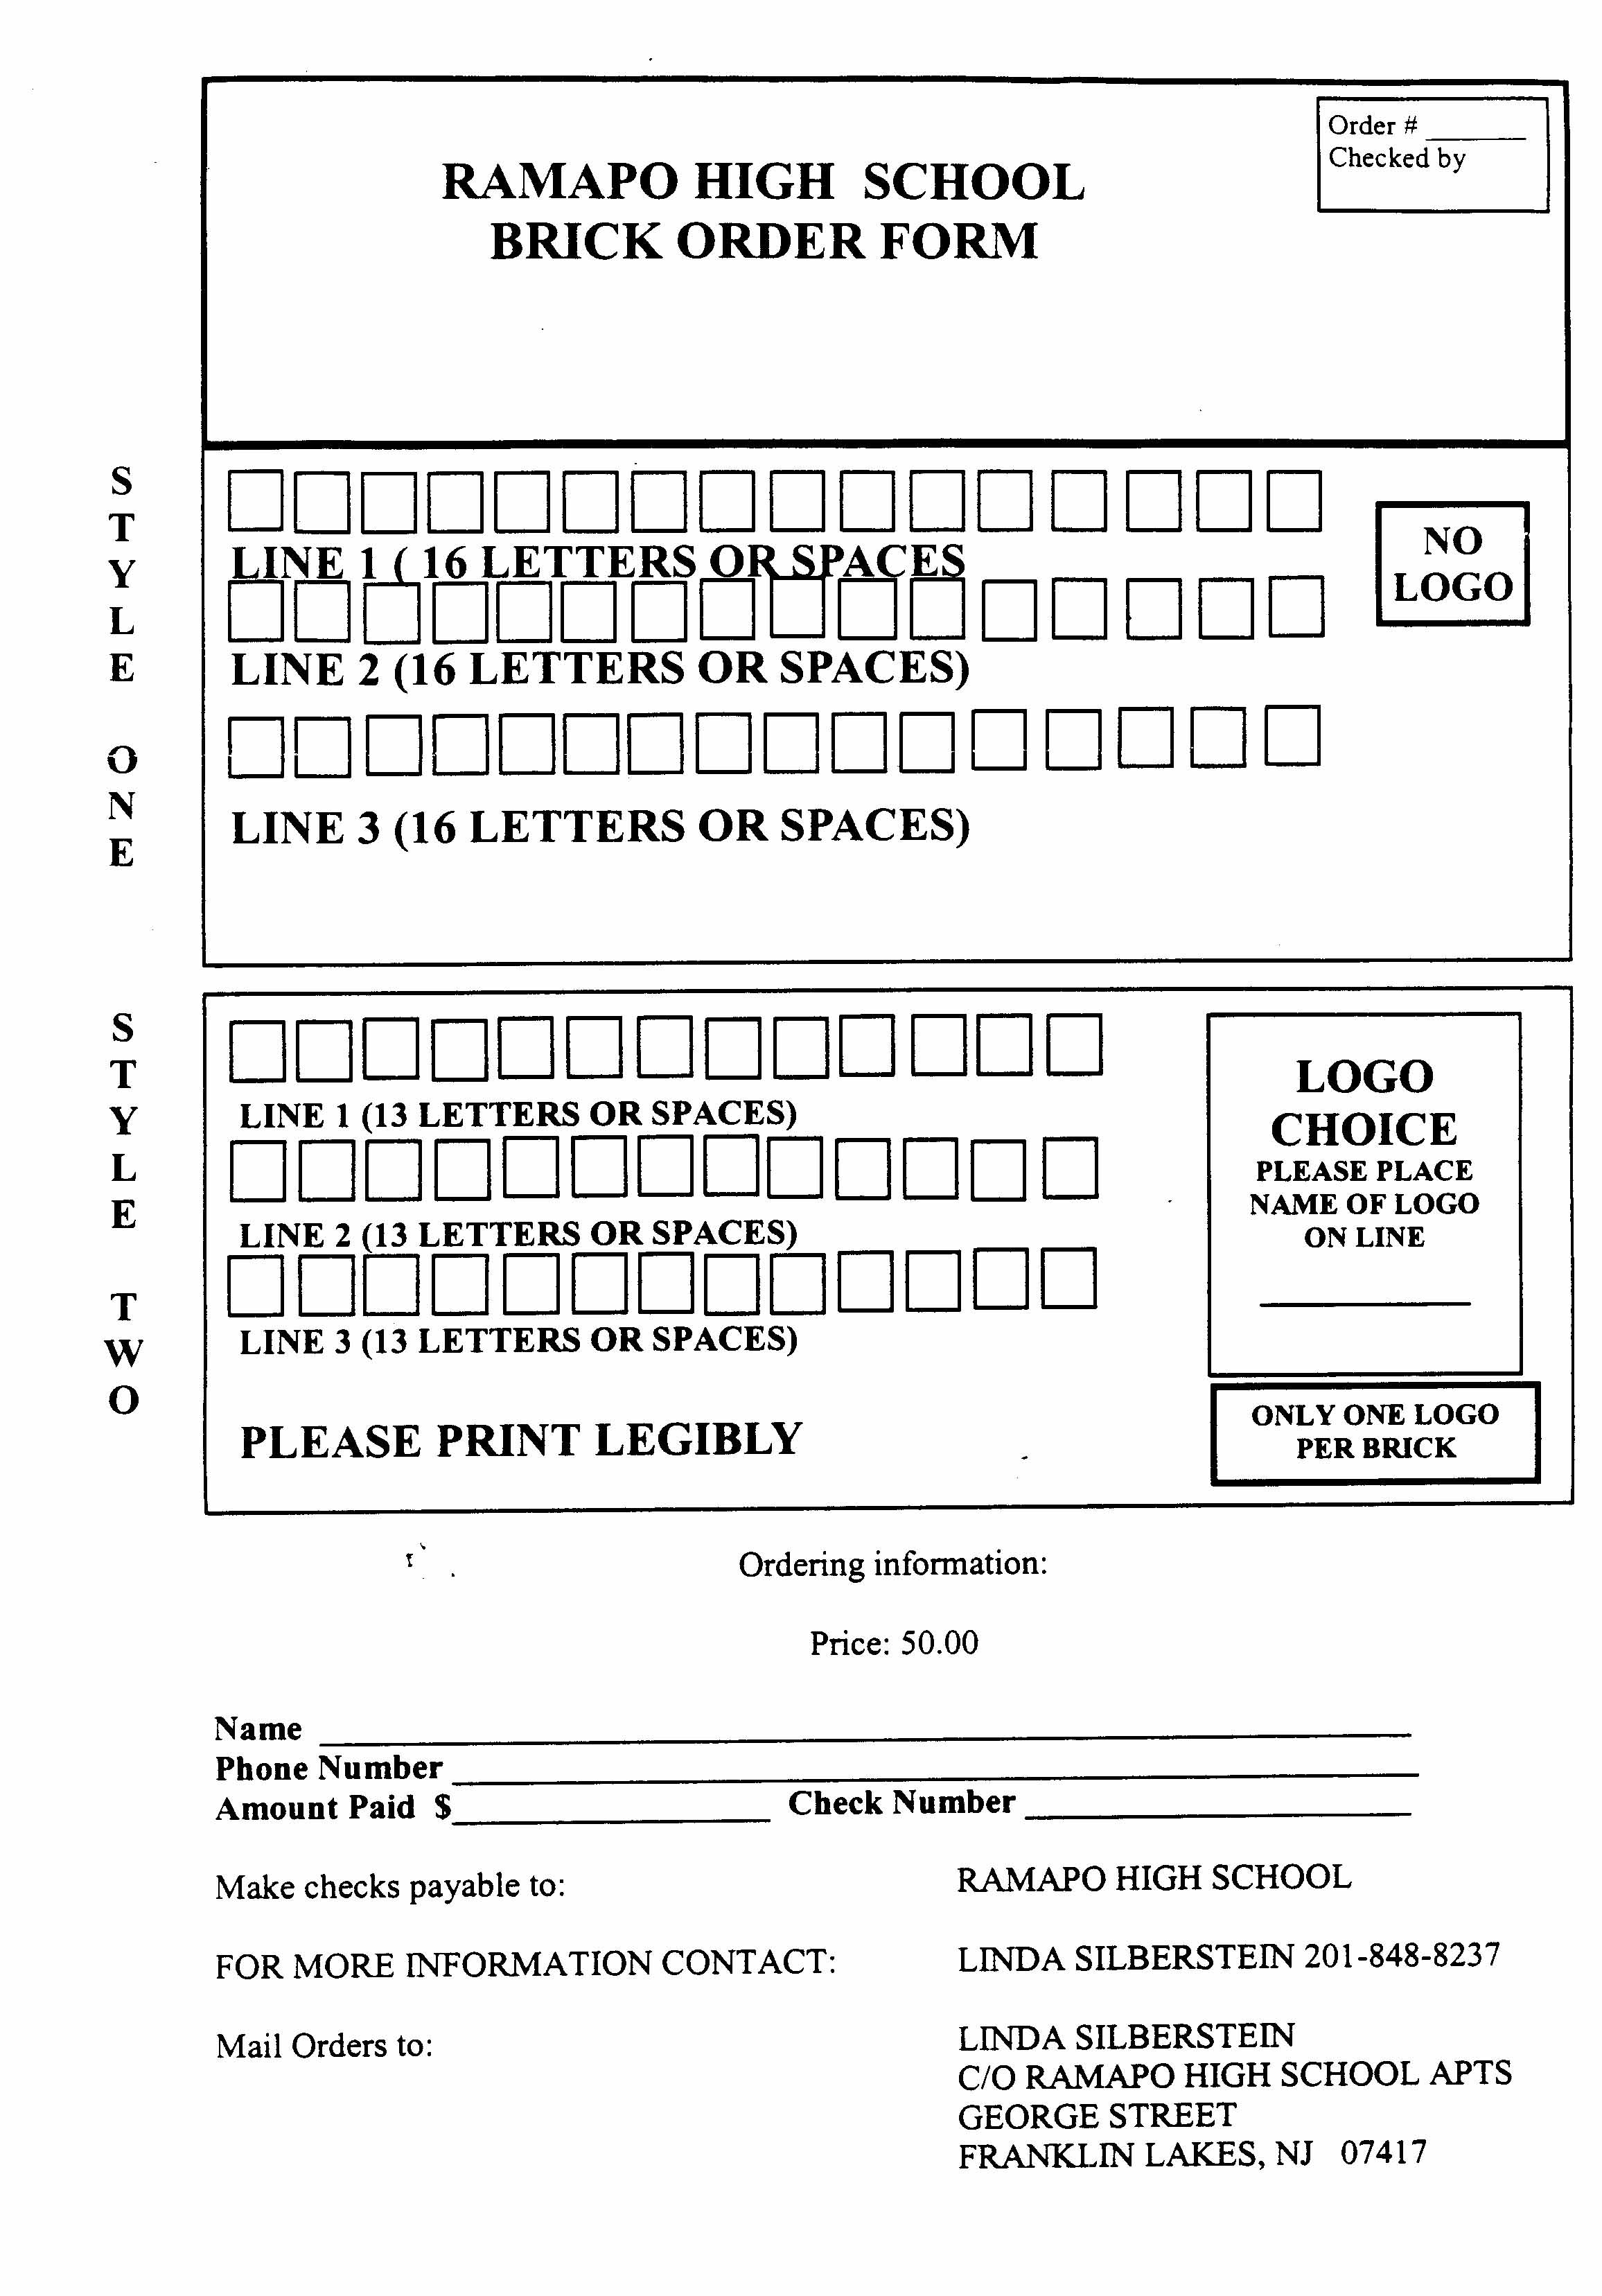
An Interview with the Founder (continued from page 3)

News from Your Classmates
(Continued from Page 5)

Inside.... your first edition of

Ramapost

A Publication of the Ramapo High School Alumni Association, Inc.

Ramapo HS Alumni Association, Inc.
P.O. Box 75
Franklin Lakes, NJ 07417-0075
ADDRESS CORRECTION REQUESTED

